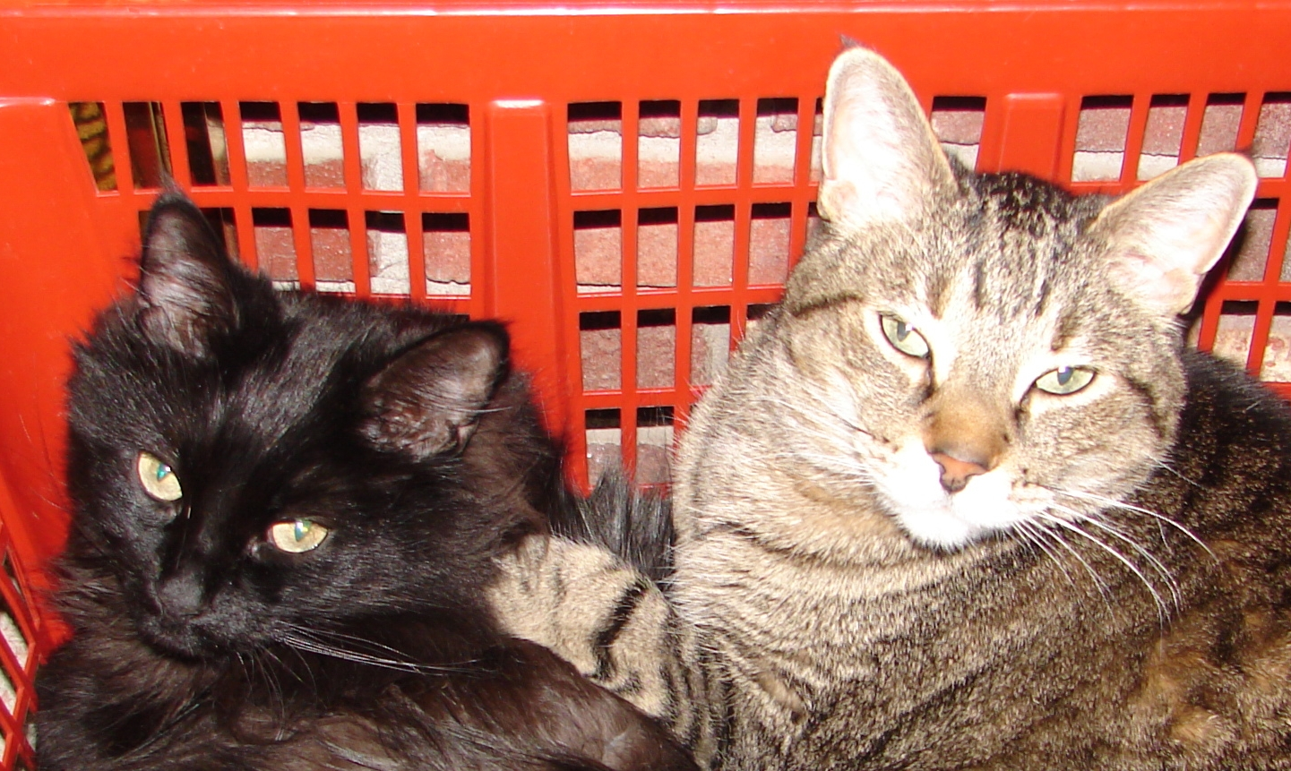 At the Borcherts, Summer Solstice, 2008 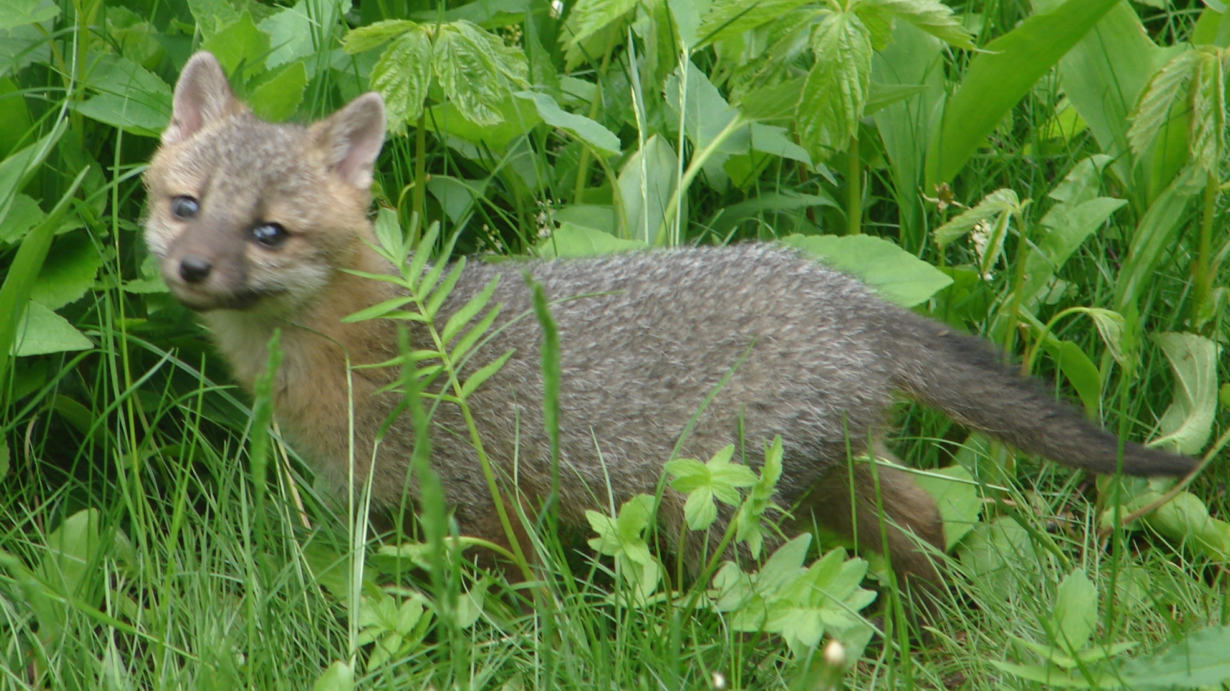

Welcome to our dual-purpose communication – notifying you of our change of address and also making up for the lack of a holiday letter last year. We had a little trouble keeping up with the seasons. We started this letter around the 2007 winter solstice. However, one thing led to another, and now we offer you our year-and-a-half update, in honor of the first day of summer.

2007 was one of our busiest ever, partially because we were incredibly bad at predicting how crazy our life would be if we added “one more thing”. As 2007 started, we were in Egypt with our family, visiting niece Julie before she transferred to Bangladesh (she works for the state department in international development). This was a fabulous trip, sampling pyramids, the Nile, the Red Sea, Cairo, and Alexandria. Mostly, we want to go back to Aswan. On the enclosed pictures, we are riding horses near Giza on Christmas Day, 2006.

After the spring semester was done, we took advantage of Pat presenting a paper in Catania, Sicily, and we went exploring. We experienced a genuine Sicilian scam, but also enjoyed ancient Siracusa, getting lost in medieval hill towns, and hiking on recent lava flows on Mt. Etna.

In late June, we biked over 100 miles on the Michelson Trail through the Black Hills with our good friends, the Swansons. It was hot, it was tough going at times, but it was great to be out in the open on the old rail line, seeing Crazy Horse, Mt. Rushmore, steep hills, a gazillion deer, the Lead gold mine, and more casinos than we needed.

About this time, our son, Tom, was on his own trek. After finishing his Masters of Science in Computer Science at the University of Colorado in Boulder, Tom (and a cat) moved to England to join Katharina, who has now finished her second year in medical school at Cambridge University. Before he left, we went on a quick trip to the BWCA with both Mike and Tom, where we saw beavers, a bear, some burned areas, and more rain per hour than we have ever experienced while in a canoe. We got out safely, though, and truly appreciated our fine lunch in Grand Marais.

During the second half of the summer, we attended two weddings. In July, we traveled to Rochester, NY, to attend the fine wedding of Eric Werness to his college sweetheart (Mark and Val Werness are college friends of ours). We took this opportunity to explore the Finger Lakes, camping on Cayuga Lake and hiking next to some fabulous waterfalls. In August, we traveled to San Francisco for nephew Erik Anderson’s wedding, and spent time with Pat’s close friend from high school, Stephanie. She graciously put up with lots of Borcherts who converged in the Bay area for the Zoo wedding (the same zoo where the lion got loose later – we had no such problems).

Tom invited us to his new home in England for Christmas, so Dave and I spent a wonderful time in Cambridge taking walks in the afternoon and playing board games in the evening, and then traveling to Buhl, Germany, to visit Katharina’s family. The Black Forest, Strassburg, and Freiburg were all in their holiday finery, just for us. Tom is now working at the Microsoft research facility in Cambridge, thoroughly enjoying his role at the intersection of primary research and operational software (no, he does not work on the operating system, so don’t blame him when your computer crashes).

Most of the rest of our time from September, 2007 to June, 2008 was spent preparing to move. We spent the summer of 2007 trying to figure out how to turn our first “fixer-upper” house in Duluth into something it wasn’t. In August, we eventually gave up, and then found the “perfect” house – reasonably small, with a great view of Lake Superior, and something we could fix up the way we wanted it. It turned out that we had a lot more fixing up to do than we thought, on both houses: one to sell and the other to move into. In April, 2008, we moved into the “new” house, and in late May, we put our Fern Ave. house up for sale in the worst real estate market since 1982 (the last time we found ourselves owning two houses). Hence, the new address on our return address on the envelope. Our phone number stayed the same, and our new address is 1514 Skywood Lane, Duluth, MN 55805. Note that we brought our two cats with us (pictured above), and also have a family of 8 foxes living near (and sometimes under part of) our new house.

While all this was going on, our other children’s lives were also shifting dramatically. Michael and Elizabeth are the proud parents of a beautiful girl, Amelia Rose Borchert, born March 24, 2008. It hasn’t slowed them down much, but it sure has cut into their sleep. Amelia keeps us informed of her progress through emails she sends, usually accompanied with a few fabulous pictures of her new skills (smiling, grabbing Mike’s nose, etc).

Karen is also making a major transition. She graduated in mid-June from Carleton, with a major in Biology, concentration in Biochemistry, and a certificate in German. She and her friend Russell have moved into the third floor of Mike and Elizabeth’s house in south Minneapolis. Karen will be attending the University of Minnesota Medical School in the fall, Russell is looking for a job in the University environment (hopefully related to student affairs), and they will both help babysit little Amelia.

So all five of us have gone through at least one major transition in the last 18 months. Looking ahead, there should not be any major changes in the next few years, which is very reassuring. That is, except for one minor thing:

Starting in January (2009), Dave and I will be living in England for 6 months. I will be teaching UMD students who are part of a Study in England Programme in Birmingham from January through May of 2009, and probably staying in England through June, 2009. First of all, we sincerely hope we do not still own two houses by then (anyone need to rent a house?), and second, we will be delighted to host anyone who would like free lodging in Birmingham. We will have a two-bedroom flat, and would love to have visitors. Just let us know when you would like to visit, and we will put you on the schedule! (www.borchert.com/EnglandSchedule)

We are all healthy and settled into our new routines. We hope you are also enjoying the summer and looking forward to life’s never-ending adventures.

Pat and Dave

